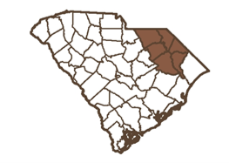
2024 Board Meeting Schedule
PEE DEE REGIONAL COUNCIL OF GOVERNMENTS
2314 PISGAH RD FLORENCE, SC 29501
P.O. BOX 5719 FLORENCE, SC 29502
(843) 669-3138
peedeecog.org

All Meetings are held on the 2nd Monday of the month @ 6pm
January 8th, 2024
February 12th, 2024
March 11, 2024 (Full Board)
April 8th, 2024
May 13th, 2024
June 10th, 2024 (Full Board)
July 8th, 2024
August 12th, 2024
September 9th, 2024 (Full Board)
October 14th, 2024
November 11th, 2024
December 9th, 2024 (Full Board)

